**Student Questions**

Learn about the internals of a standard PC case by examining physical samples and selecting and labeling images found on-line. Gain deeper knowledge by researching and reporting on specific components.

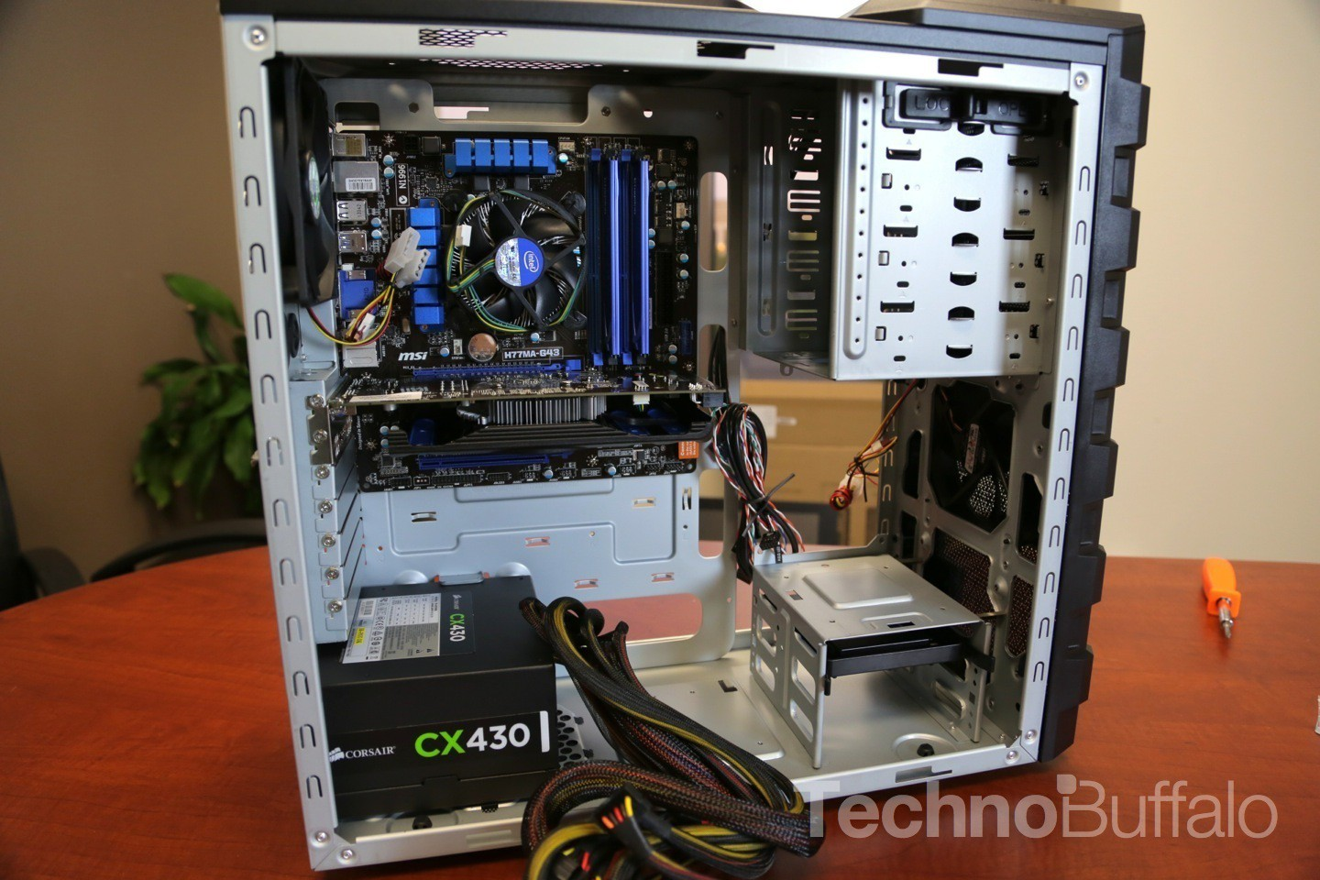

CPU and CPU fan

Power Supply

Motherboard

Optical Disc Drive

Hard Disk

Cooling fan

PC Tower Case

1. Find one (or morally show the internals of a PC Tower Case.   
   (i.e. Google images using keywords “PC Case Internals”)

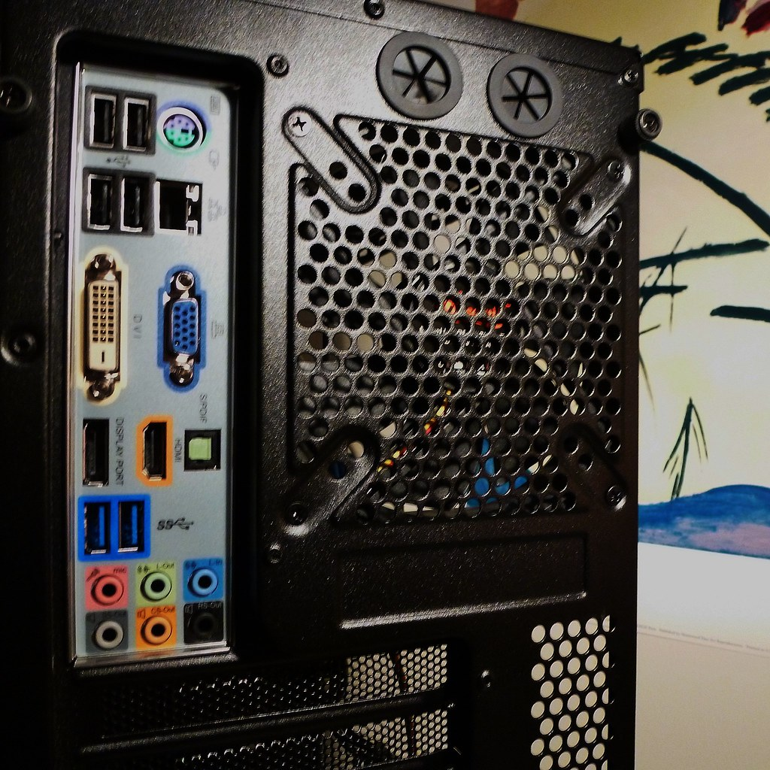

Monitor Port (DVI)

Ethernet Port

Audio Ports

USB Expansion Ports

1. Clearly label the following components (using arrows) on your image of the PC case internals:
   1. Motherboard
   2. Power Supply
   3. Hard Disk Drive
   4. Optical Disk Drive (e.g.DVD)
   5. USB Expansion Ports
   6. Monitor Port
   7. Audio Ports
   8. Ethernet Port
   9. Cooling Fan
2. Research more in-depth about “Hard Disk Drives”. Make notes on the following:
   1. What different versions are currently available (speed and capacity)
   2. How the capacity of the component has changed since the 1980s

PC Motherboard

1. Find one (or more) images that clearly show the layout of a PC Motherboard.   
   (i.e. Google images using keywords “PC Motherboard”)
2. Clearly label the following components (using arrows) on your image of the PC motherboard:
   1. CPU (and fan)
   2. RAM Memory
   3. Disk Drive Interface (IDE or SATA)
   4. GPU Graphics Processor (either on-board or Graphics Card)
   5. Sound Processor (either on-board or Sound Card)
   6. Wi-Fi / Ethernet Network Interface (either on-board or Graphics Card)

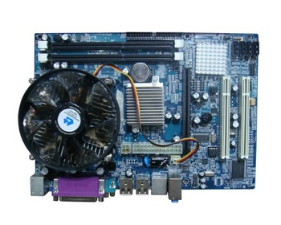

CPU and CPU fan

Onboard graphics

RAM slots

PCIE Slots (expansion card slots)

Integrated Sound Processor

Sata Ports (Hard Disk Drive Interface)

(Where Wifi/Bluetooth Card would go)



1. Research more in-depth about “CPU Processor Chip”. Make notes on the following:
2. What different versions are currently available (speed and capacity)
3. How the speed of the component has changed since the 1980s

A. The two main CPU brands are **Intel** and **AMD.**

B. The different speeds of CPUs have changed in that they have are much faster in GHz than CPUs in the 1980s. They are also smaller but more powerful.

Peripheral Devices

1. Find one (or more) images that clearly show the layout of the back of a typical PC tower case.   
   (i.e. Google images using keywords “Back Of PC Tower”)  
     
   
2. Clearly label the following components (using arrows) on your image of the back of a typical PC tower case:
   1. Power cord and power switch
   2. Monitor Interface (VGA or DVI or HDMI)
   3. Mouse Interface (USB or PS/2)
   4. Keyboard Interface (USB or PS/2)
   5. USB Ports
   6. Audio Inputs / Outputs
   7. Ethernet Interface

1. Research more in-depth about “External Portable Storage”. Make notes on the following:
2. Floppy Disks - one of the oldest forms of storage, very small capacity.
3. CD-ROM / DVD / Recordable CD/DVD - a storage type still used somewhat in the present day, the storage was stored on bumps on a disc. There were many revisions of CDs that increased storage capacity and read speeds.
4. USB Memory Drives - USB memory drives are small gum stick sized pieces of storage. They use a type of storage called flash memory which is a fast type of storage. The sticks use a USB-A connector to connect to computers.
5. Compact Flash Memory- Can be found in many compact forms such as SD cards. The memory used for these types of storage is called “flash memory” and was created by SanDisk.
6. Cloud-Based Storage- Let’s the user save and store data (i.e pictures and documents) without taking up any space on their own storage as cloud-based storage is saved on the “cloud” aka servers.

**Presentation Outline**

Explore the development and features of a specific PC hardware component through deeper research and investigation. Work in partners to create a short presentation. Deliver the presentation to the class.

Each group will research a unique PC hardware component. Your specific topic will be assigned from the list provided below.

**Presentation Structure**

1. Explain what the PC component does and how it fits together with other components to make up a fully functioning PC.
2. Explain how the PC component works. Provide a diagram (image) showing the main parts of the component.
3. Research the current state of the art of the component in terms of speed, capacity (size), and other related factors.
4. Research online suppliers that sell the PC Component. List the specifications for the available products and the cost (price).
5. Research how the PC component has changed and evolved since the early days of PCs in the 1980s. Cover each of the following topics separately:
   1. Component Speed
   2. Component Size / Capacity
   3. Two other specifications specific to the PC component (ask Mr. Nestor)

**PC Component Topics**

|  |  |  |
| --- | --- | --- |
| **Topic** | **Partner 1** | **Partner 2** |
| CPU Microprocessor Chip |  |  |
| Motherboard Layout |  |  |
| Computer Graphics |  |  |
| Sound & Audio |  |  |
| Hard Disk Drives |  |  |
| Removable Disk Storage |  |  |
| Ethernet / Fiber Connectivity | DEvan | Devan |
| Wifi / Bluetooth Connectivity |  |  |
| Mouse / Pointing Devices |  |  |
| Monitor & Display Technology |  |  |
| Printers & Output Technology |  |  |